**ASSIGNMENT NO.2**

**Create components :-**

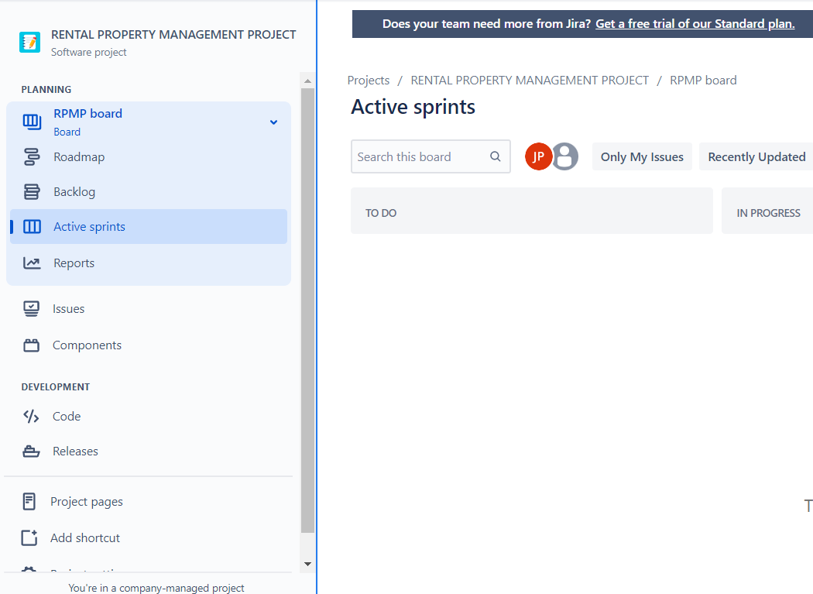

NAME OF PROJECT

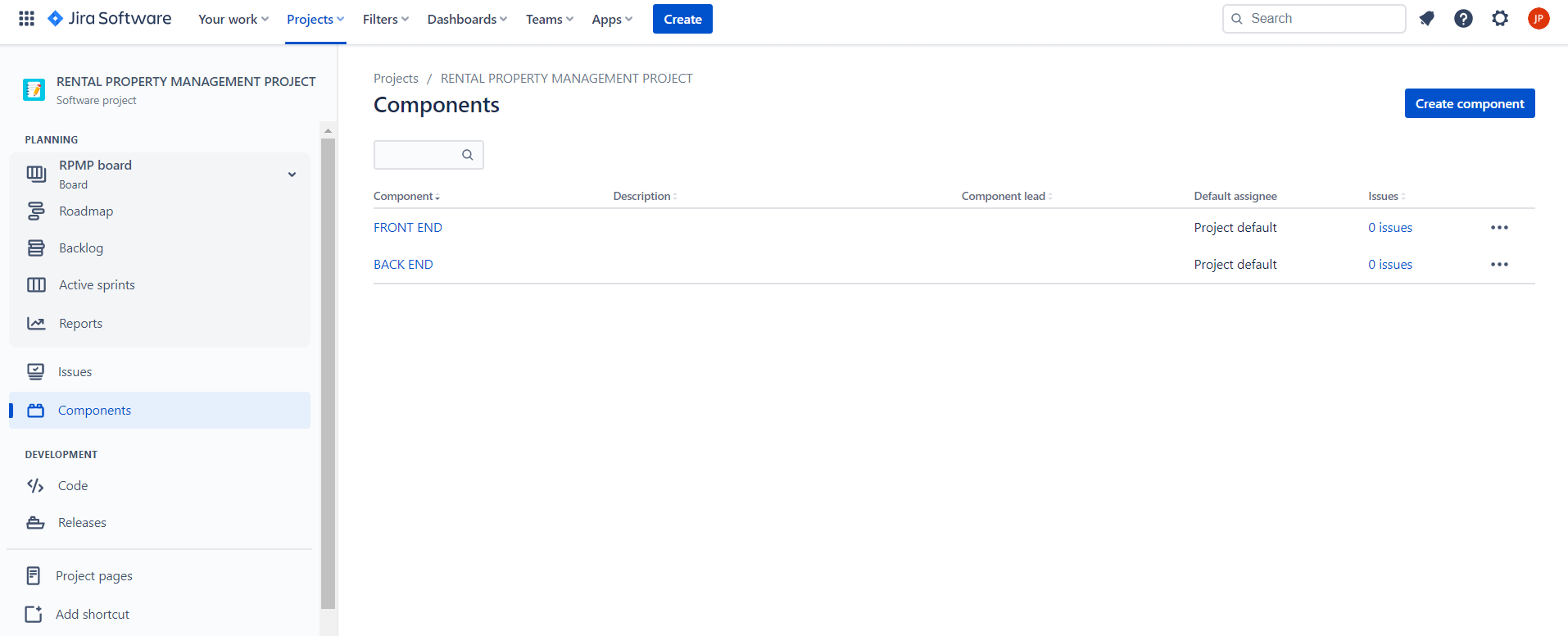

1. **Plan the version with release dates**

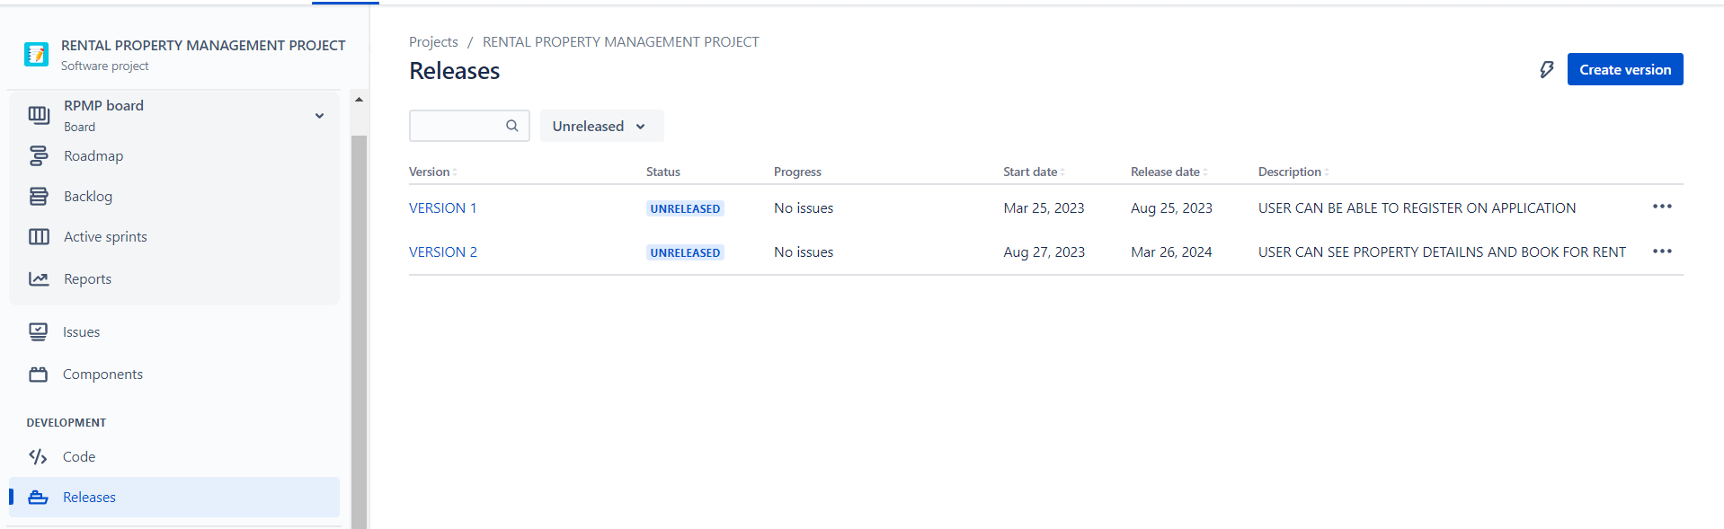

**3. Create sprint backlog, start sprint and complete sprint.**

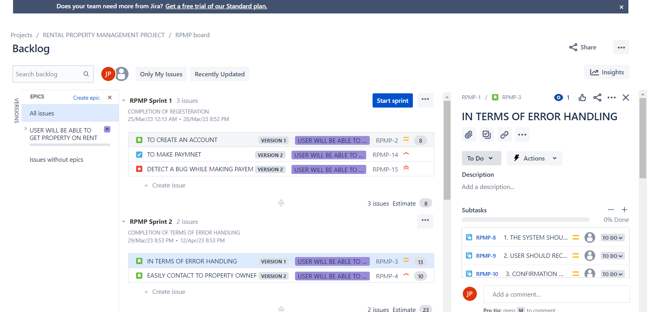

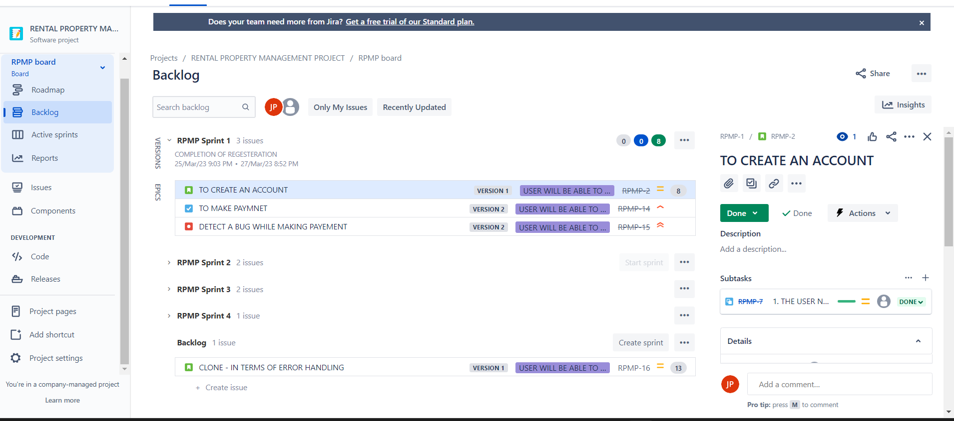

**4.Create different types of issues in the backlog.**

**-Epic - provide epic link also**

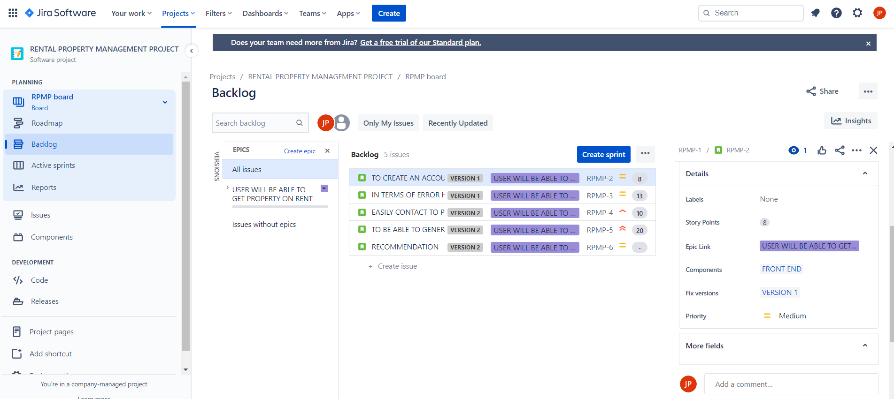

TASK

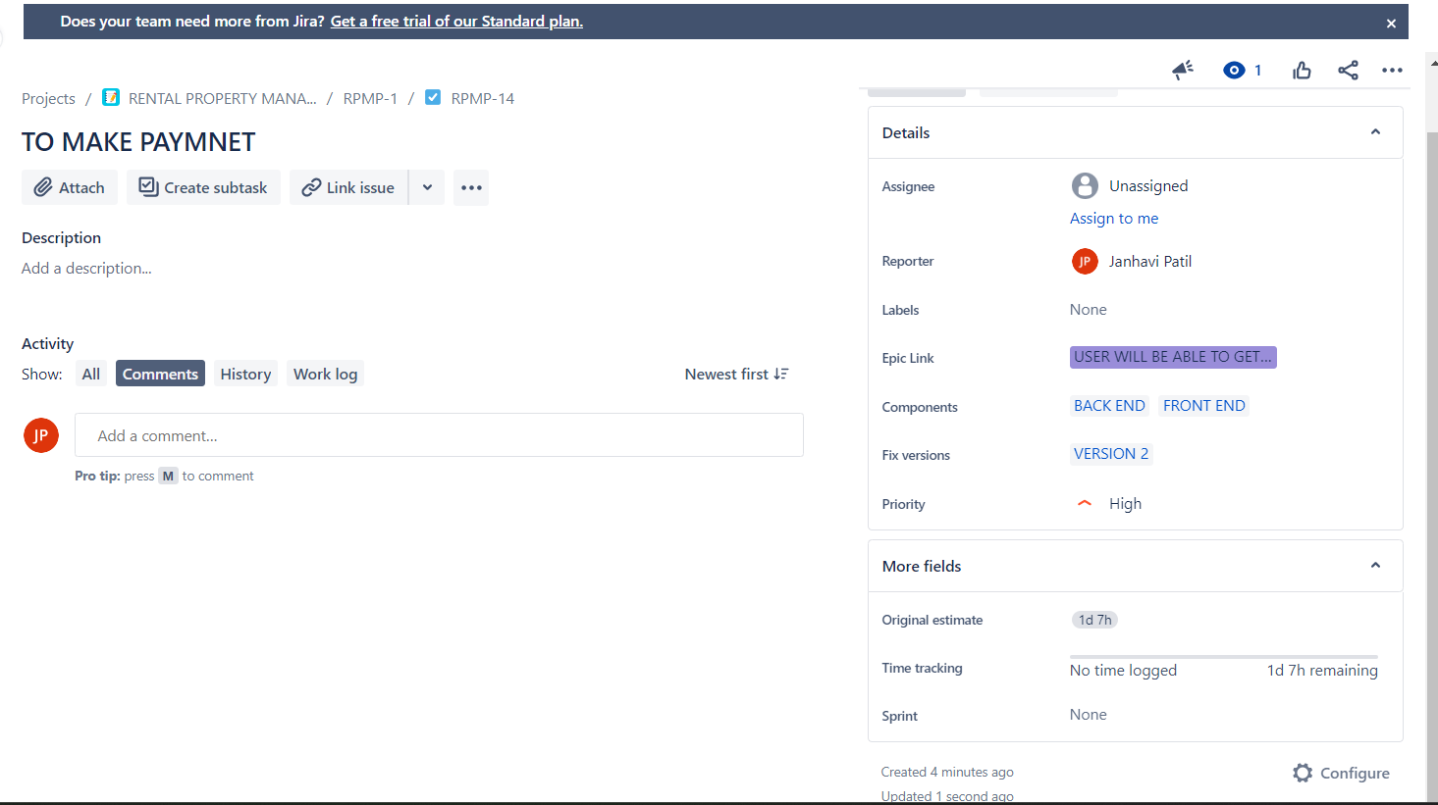

**Give estimate time –**



**Give time log work and comment it as well. -Clone the story.**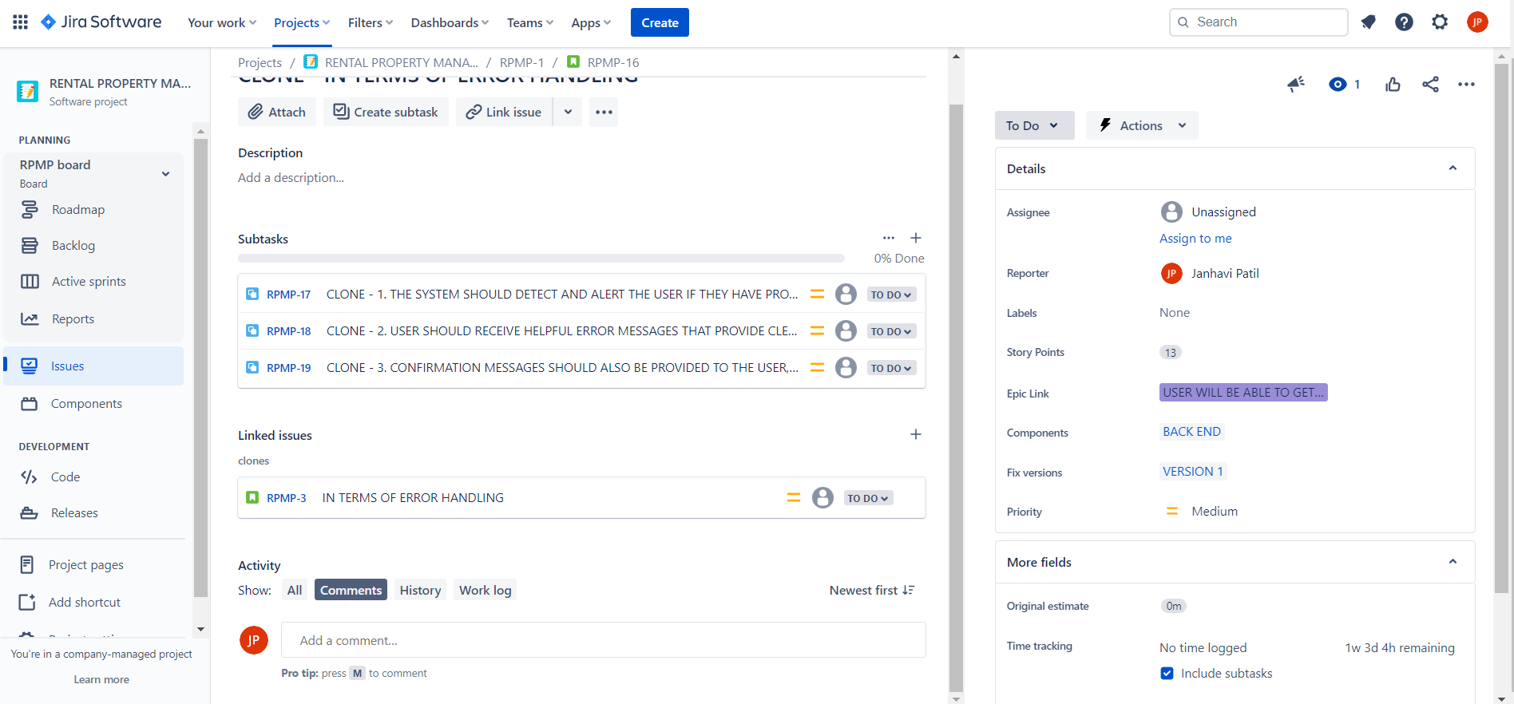

**V. Submit the screen shots of Backlog, burn down, burn up, sprint report and velocity charts for the sprint.(From your login only).**

**Burn down :-**

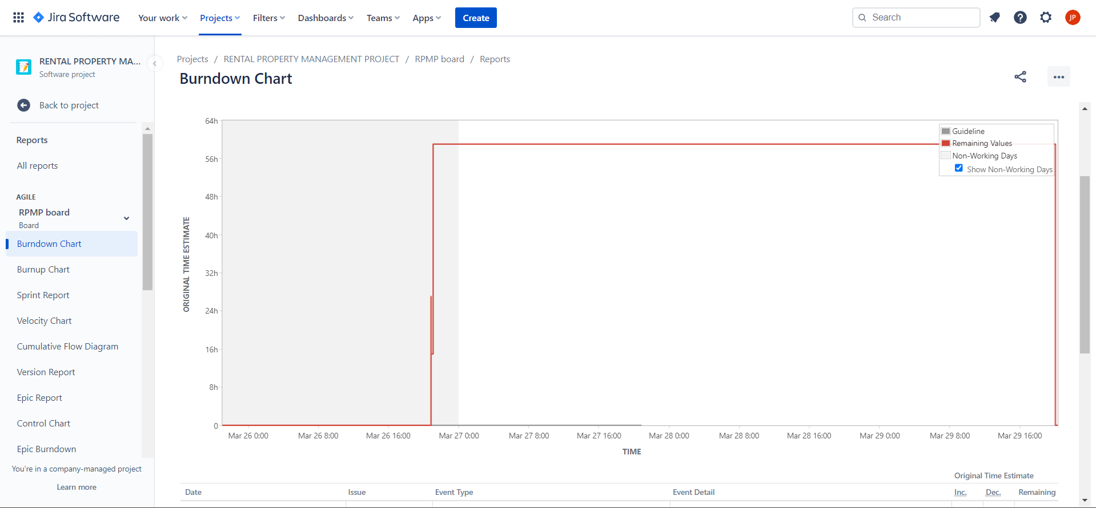

**Burn up :-**

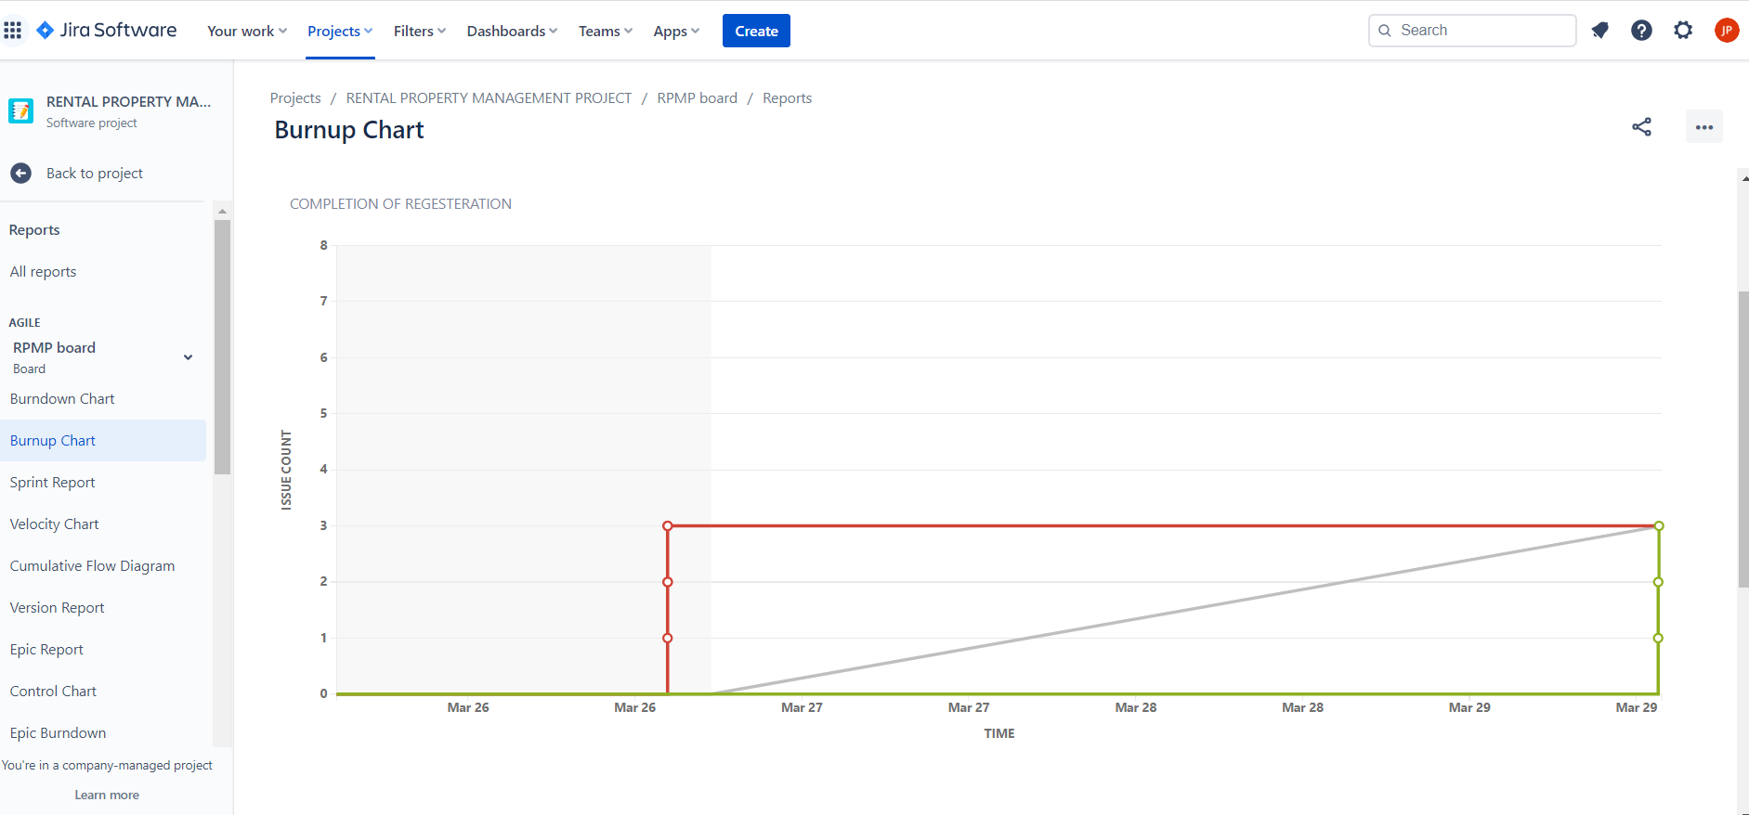

**Sprint report :-**

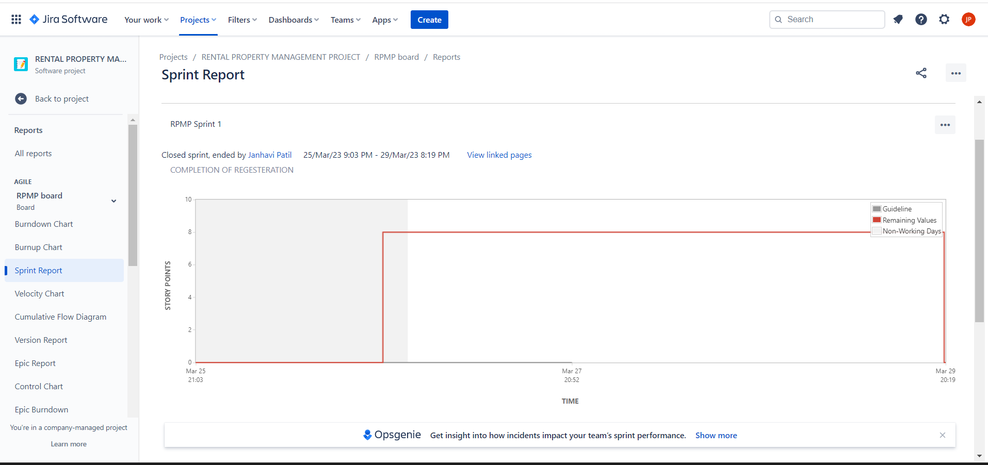

**Velocity charts :-**

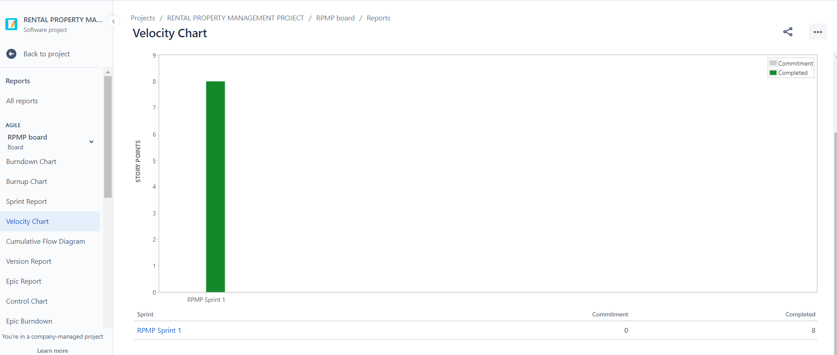

s